Alcohol Reactions
Combustion

Alcohols can be burned, either completely or incompletely.
Ethanol burns cleanly without smoking.

Oxidation

Primary and secondary alcohols can be oxidised by reacting them with an acidified dichromate (K₂Cr₂O₇ / H₂SO₄). Tertiary alcohols cannot be oxidised.

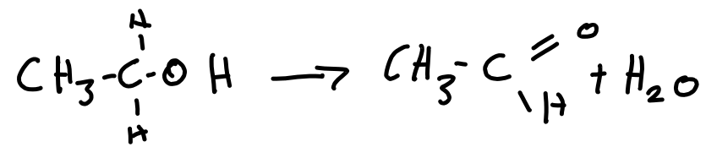
For Primary Alcohols:
- Alcohol → (distill with acidified dichromate) →aldehyde + water
- Aldehyde → (reflux for 20 mins) → carboxilic acid

These can be combined to convert alcohol to carboxilic acids by refluxing an alcohol for 20 minutes.

For Secondary Alcohols:

Alcohol → (distill with acidified dichromate) → keytone + water

Keytones are produced instead of aldehydes for secondary alcohols, because the carbonyl group of a secondary alcohol is not at the end.
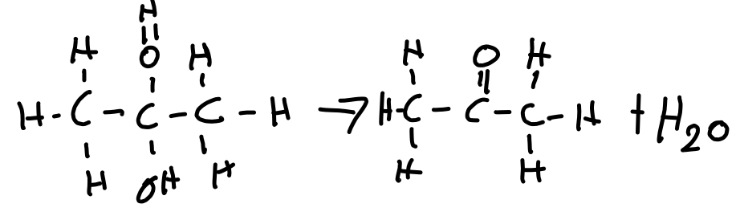

A carbonyl is a C=O bond. In an alcohol, a hydrogen cannot be removed to form the keytone, as there is no hydrogen, only a side chain.

Elimination

An alcohol is converted into an alkene and a water molecule.
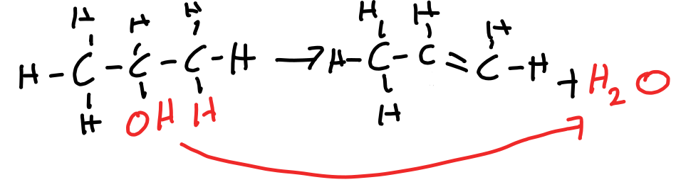

Longer alcohols produce a mixture of alkanes, including E/Z isomers.

Substitution

This is where an alcohol reacts with hydrogen halides to form haloalkanes.

Sodium halides are reacted with sulphuric acid to form hydrogen halides. These hydrogen halides then react with the alcohols to form haloalkanes and water.

C₂H₅OH + HBr → NaHSO₄ + HBr

Esterification

Carboxilic acids react with an alcohol in the presence of a sulphuric acid catalyst.
The first part of the name is from the alcohol, the second part of the name is from the carboxilic acid.

